Task 1: Practice querying JSON-formatted data by using JMESPath
Open JMESPath — JMESPath
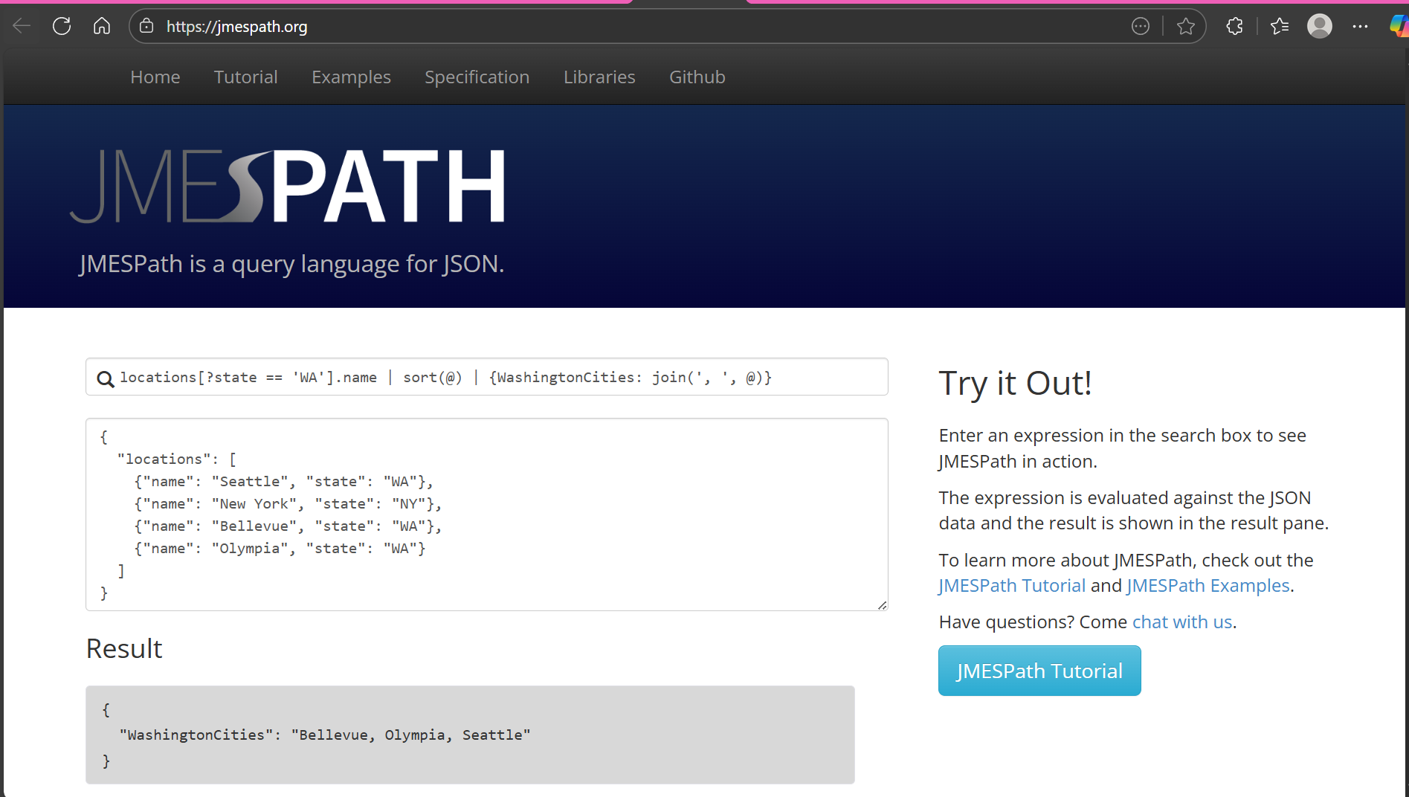
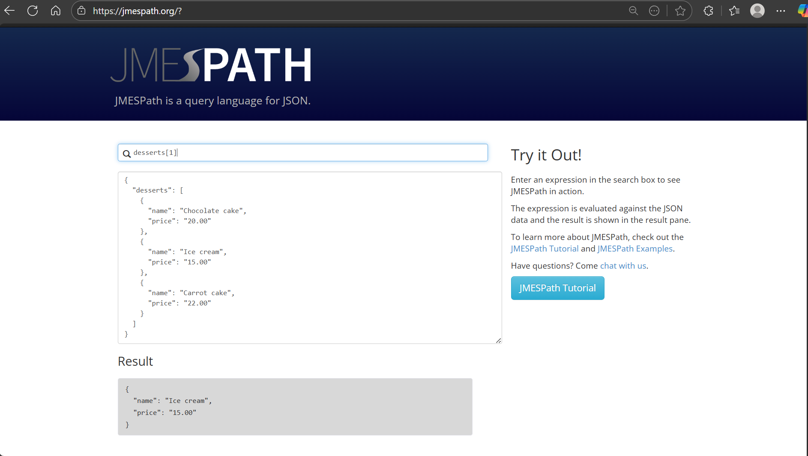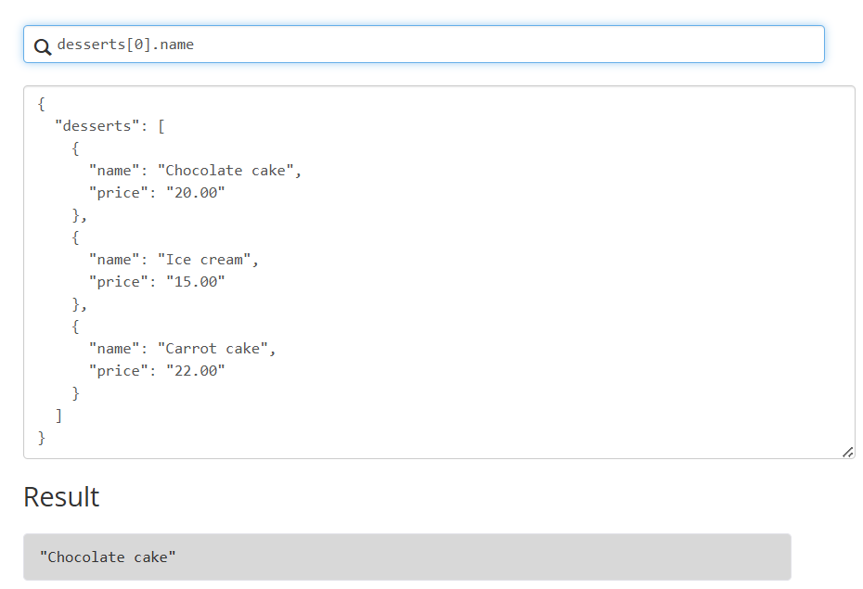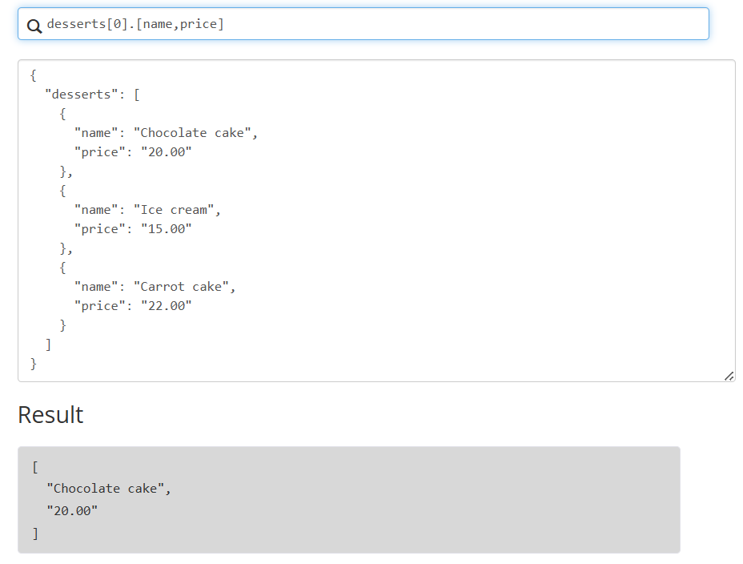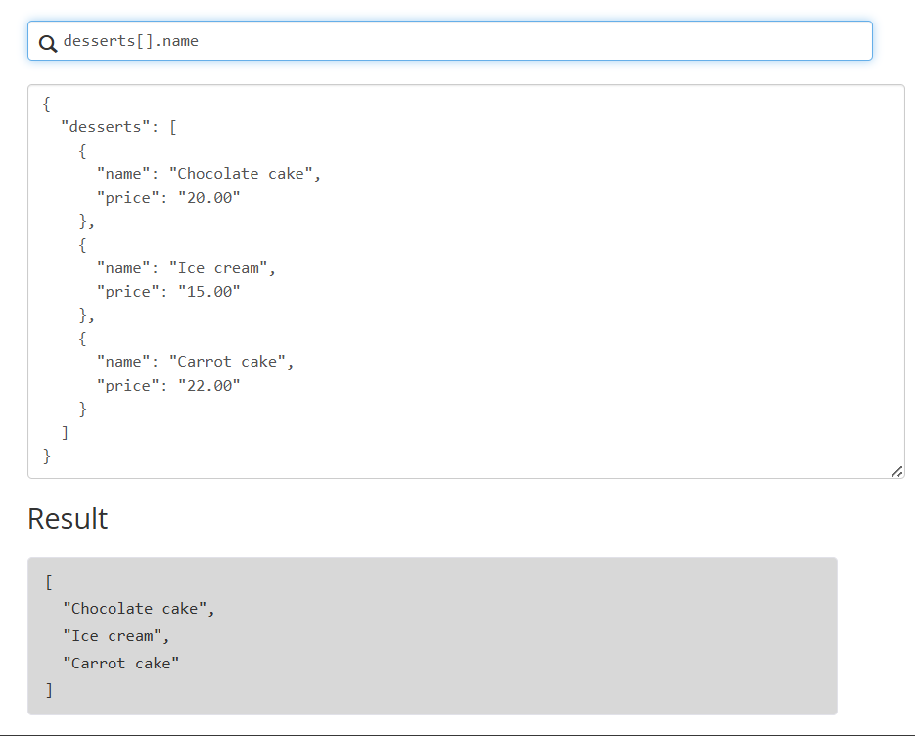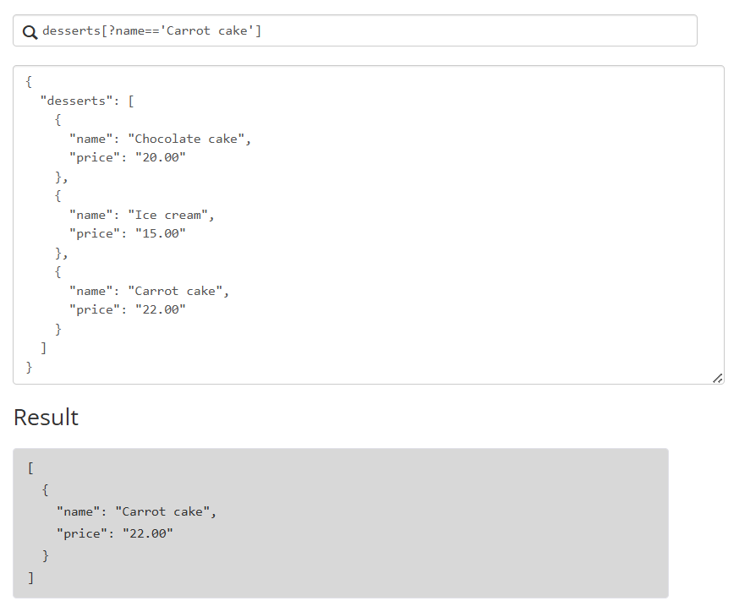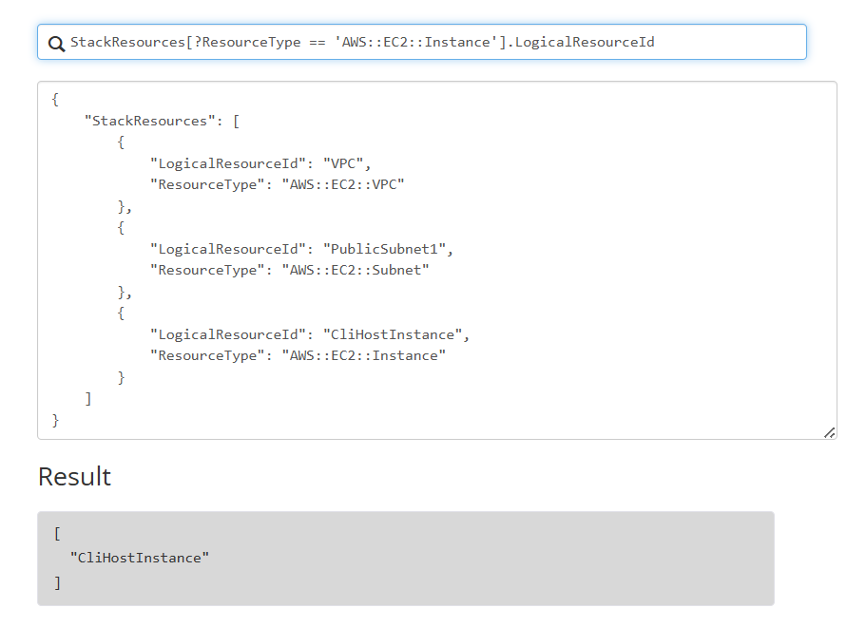
Task 2: Troubleshooting and working with AWS CloudFormation stacks
Task 2.1 for Windows: SSH to CLI Host Instance
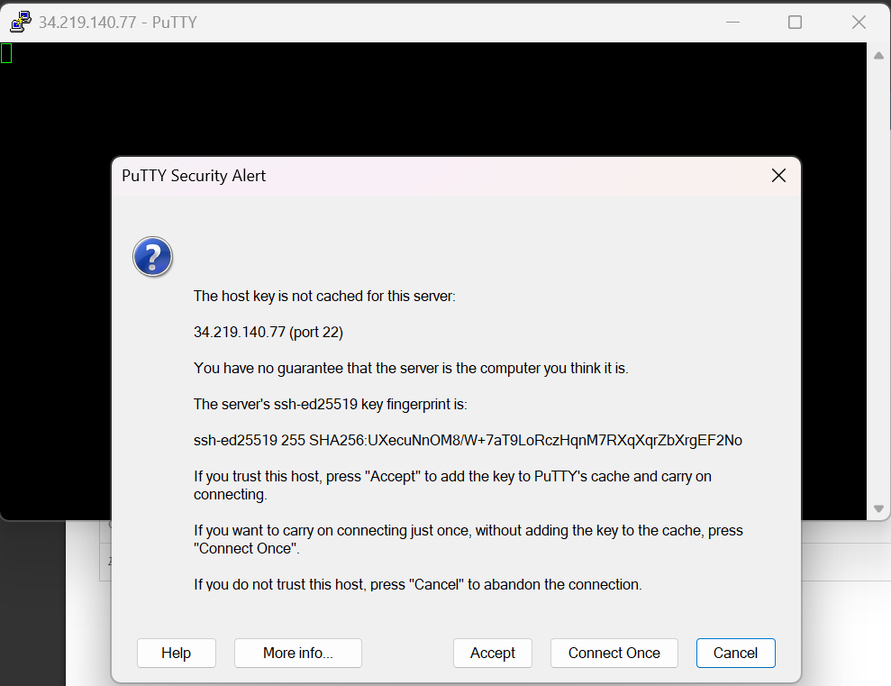
Task 2.2: Configure the AWS CLI
curl http://169.254.169.254/latest/dynamic/instance-identity/document | grep region
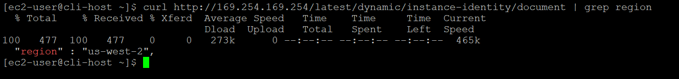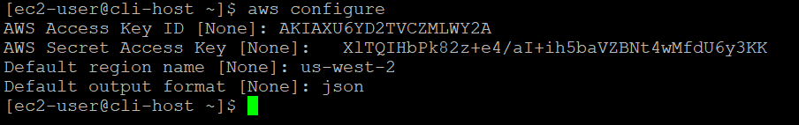
Task 2.3: Attempt to create an AWS CloudFormation stack
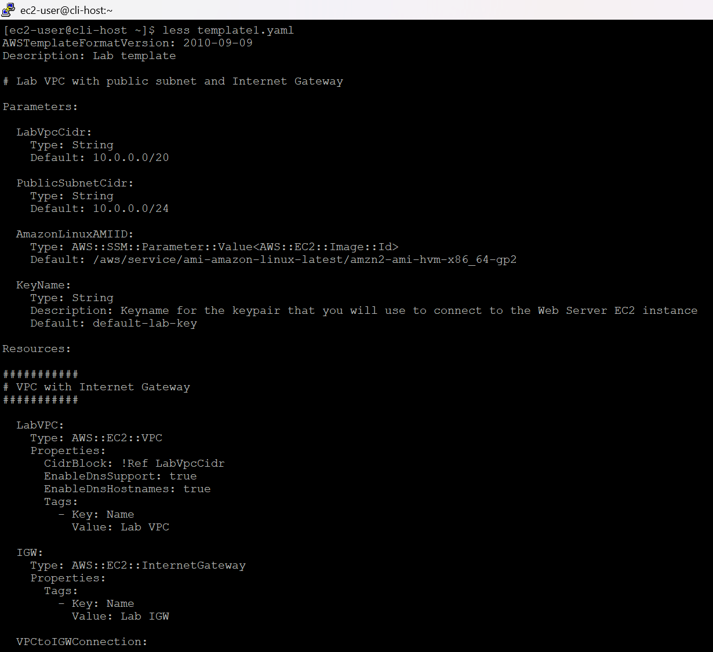
Run the following command to create a stack:
aws cloudformation create-stack \
--stack-name myStack \
--template-body file://template1.yaml \
--capabilities CAPABILITY_NAMED_IAM \
--parameters ParameterKey=KeyName,ParameterValue=vockey

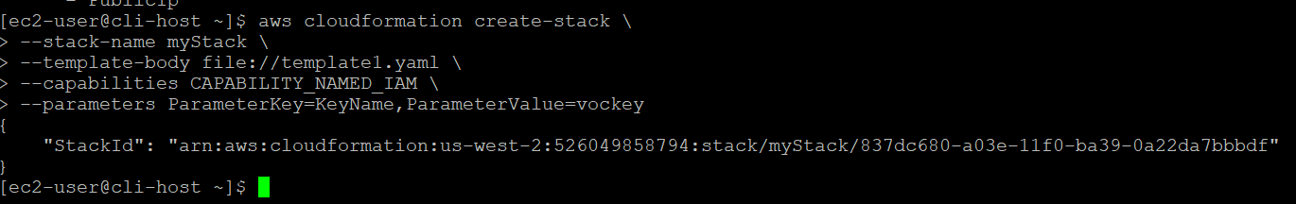
Check the status of each resource that is created by this stack:
watch -n 5 -d \
aws cloudformation describe-stack-resources \
--stack-name myStack \
--query 'StackResources[*].[ResourceType,ResourceStatus]' \
--output table
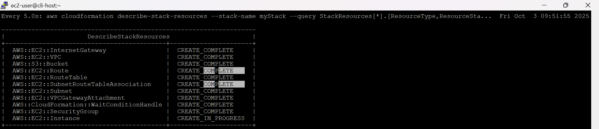
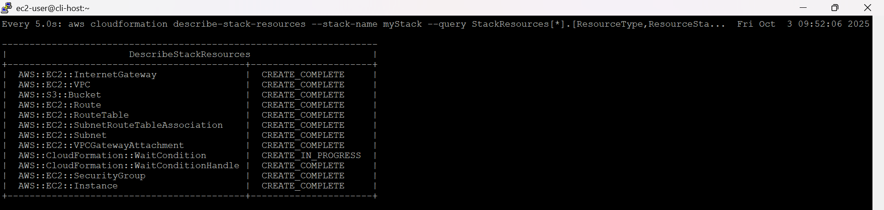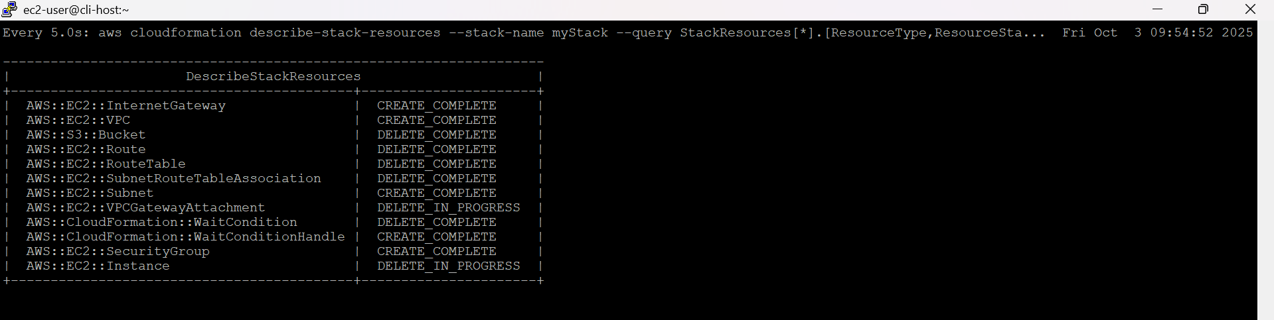watch -n 5 -d \
aws cloudformation describe-stacks \
--stack-name myStack \
--output table

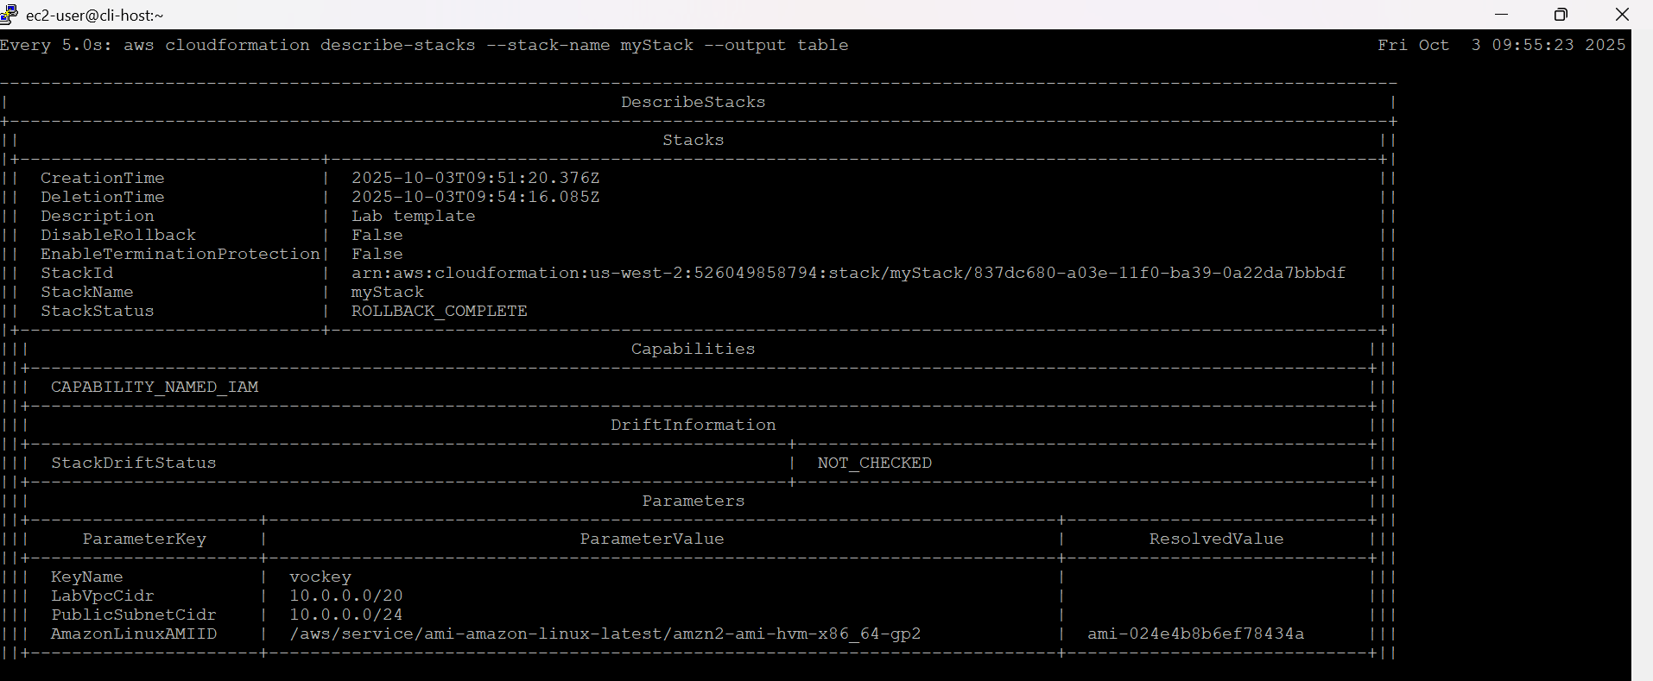
aws cloudformation describe-stack-events \
--stack-name myStack \
--query "StackEvents[?ResourceStatus == 'CREATE_FAILED']"
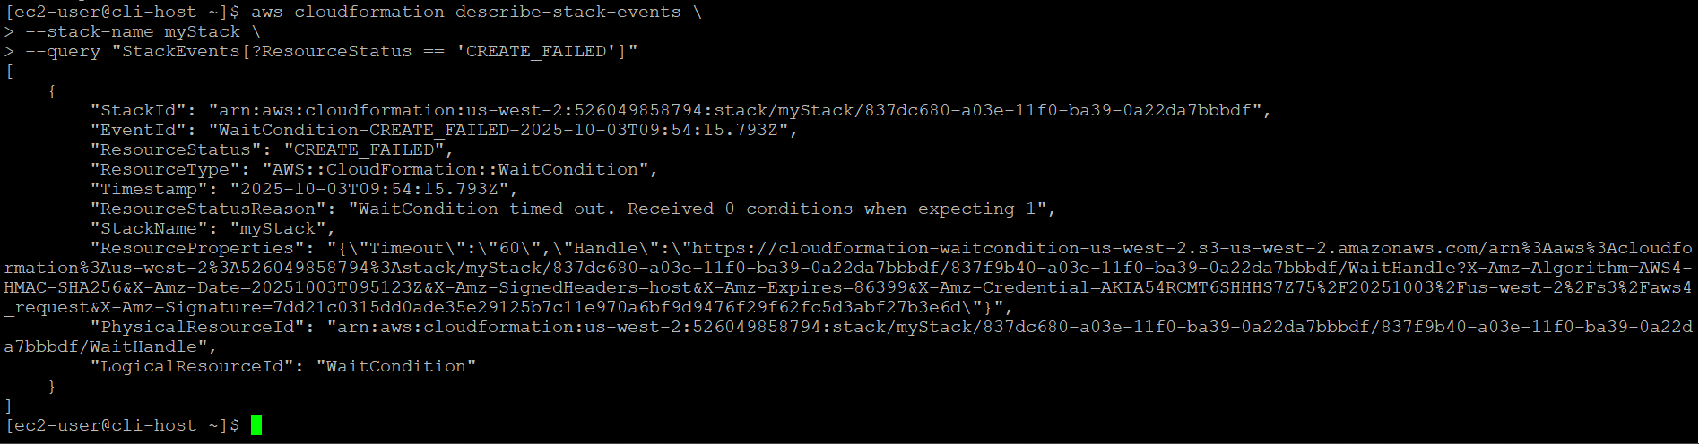
aws cloudformation describe-stacks \
--stack-name myStack \
--output table

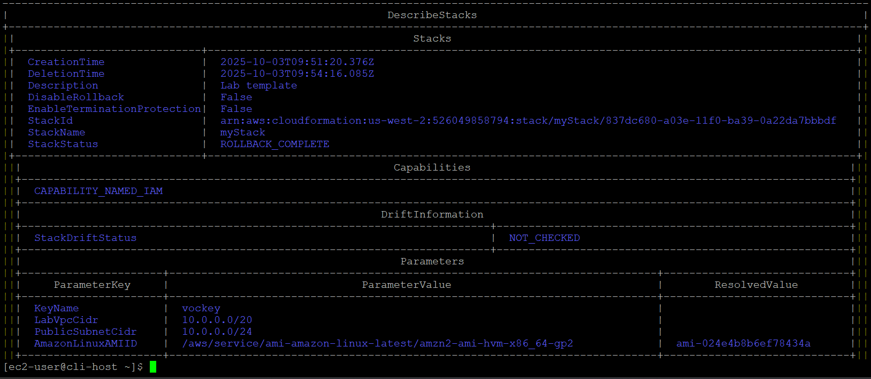
Task 2.4: Avoid rollback on an AWS CloudFormation stack
aws cloudformation create-stack \
--stack-name myStack \
--template-body file://template1.yaml \
--capabilities CAPABILITY_NAMED_IAM \
--on-failure DO_NOTHING \
--parameters ParameterKey=KeyName,ParameterValue=vockey

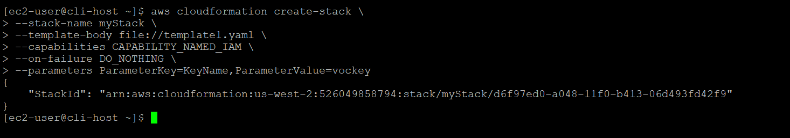
watch -n 5 -d \
aws cloudformation describe-stack-resources \
--stack-name myStack \
--query 'StackResources[*].[ResourceType,ResourceStatus]' \
--output table
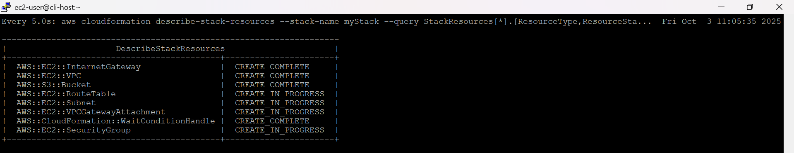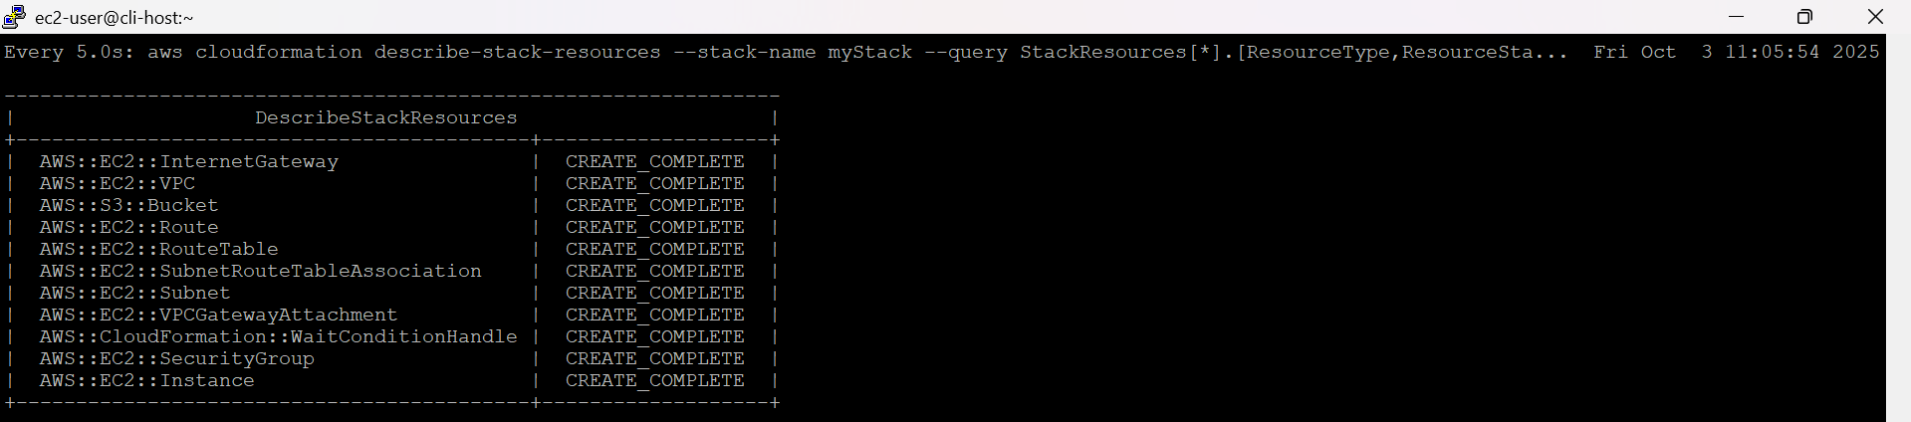
aws cloudformation describe-stacks \
--stack-name myStack \
--output table

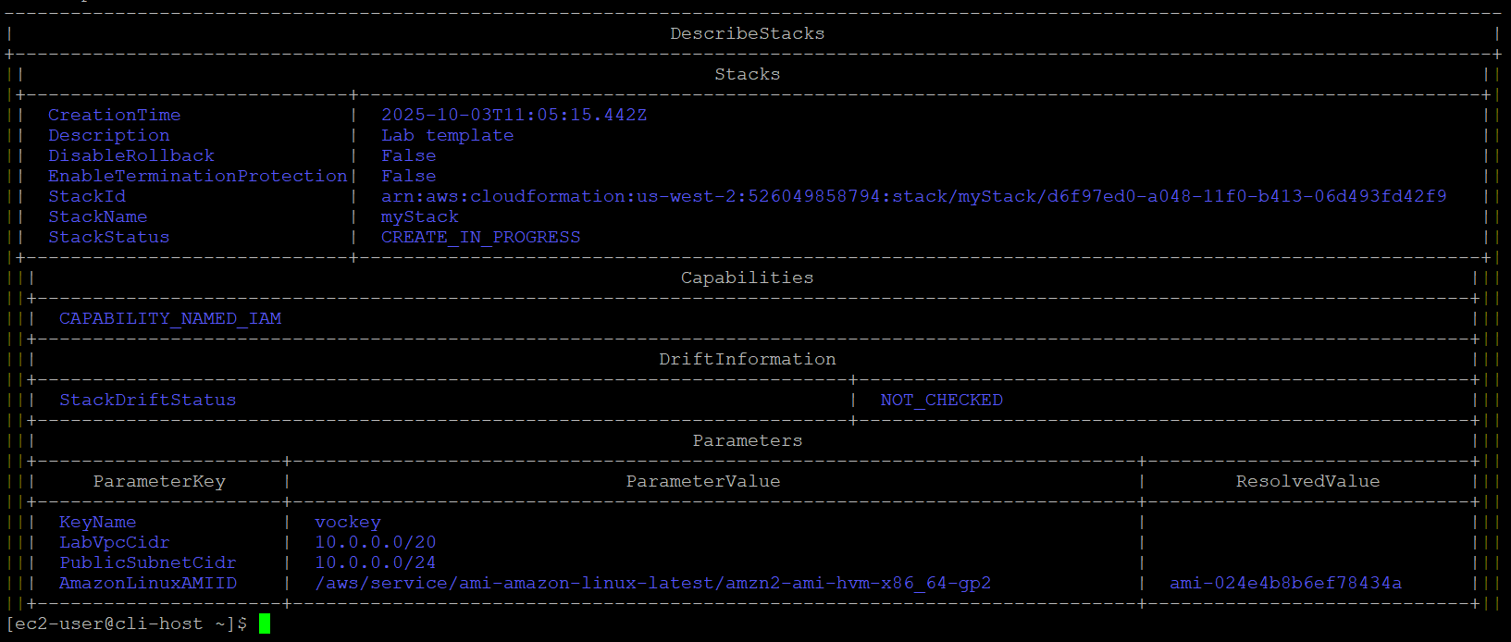
aws cloudformation describe-stack-events \
--stack-name myStack \
--query "StackEvents[?ResourceStatus == 'CREATE_FAILED']"

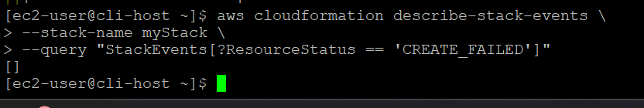
aws ec2 describe-instances \
--filters "Name=tag:Name,Values='Web Server'" \
--query 'Reservations[].Instances[].[State.Name,PublicIpAddress]'

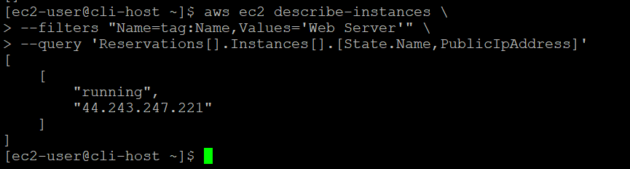
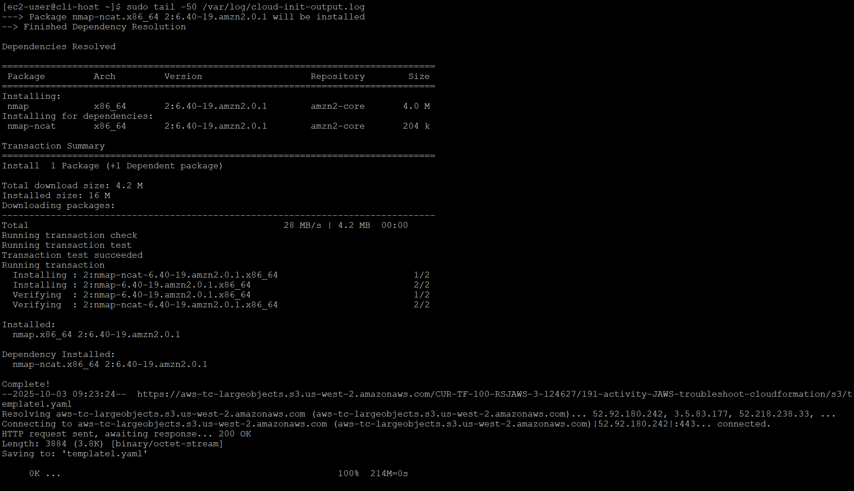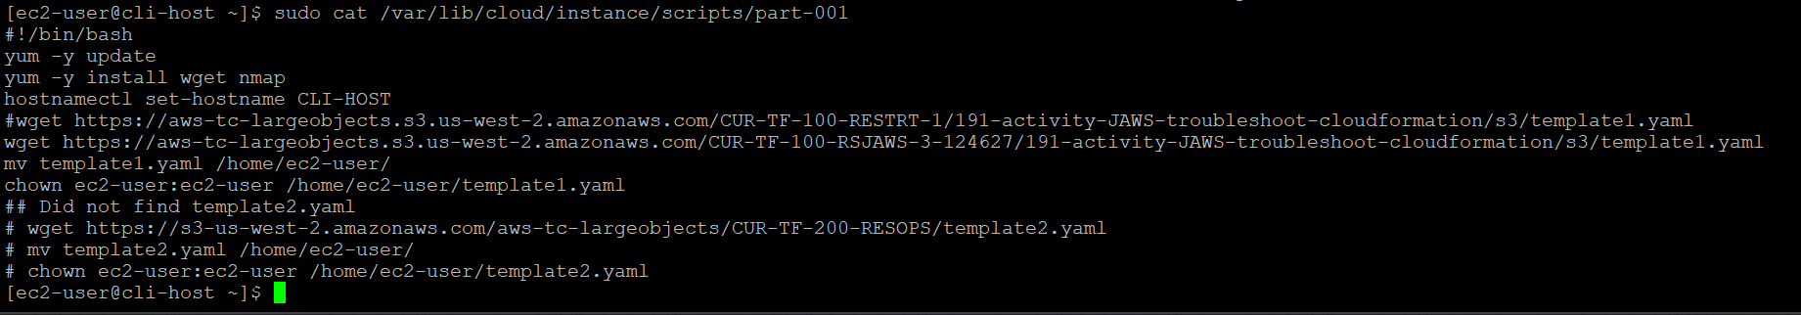

Task 2.5: Fix the issue and successfully create the AWS CloudFormation stack
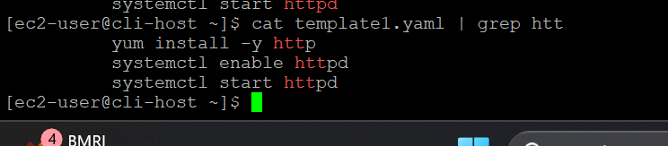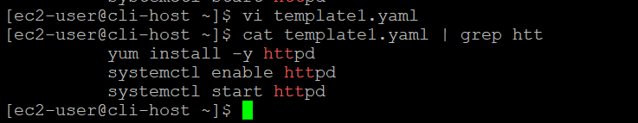

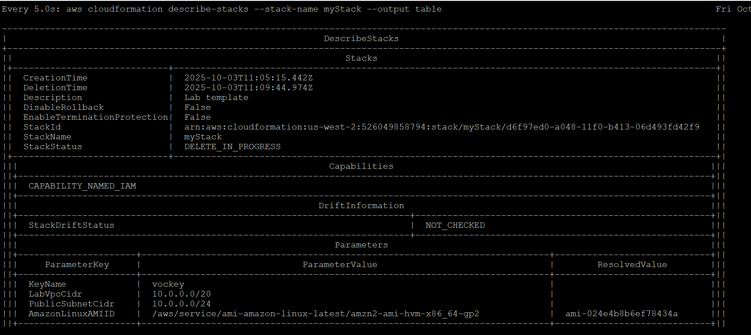
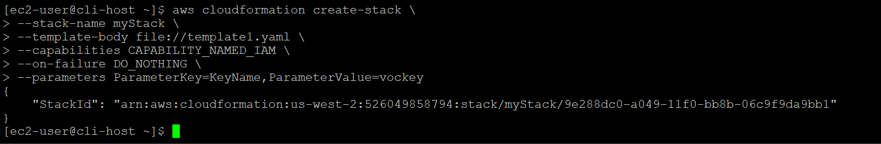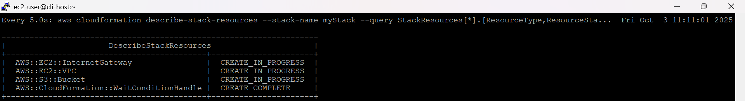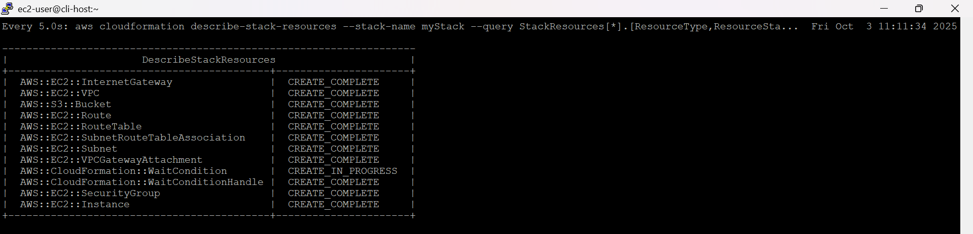
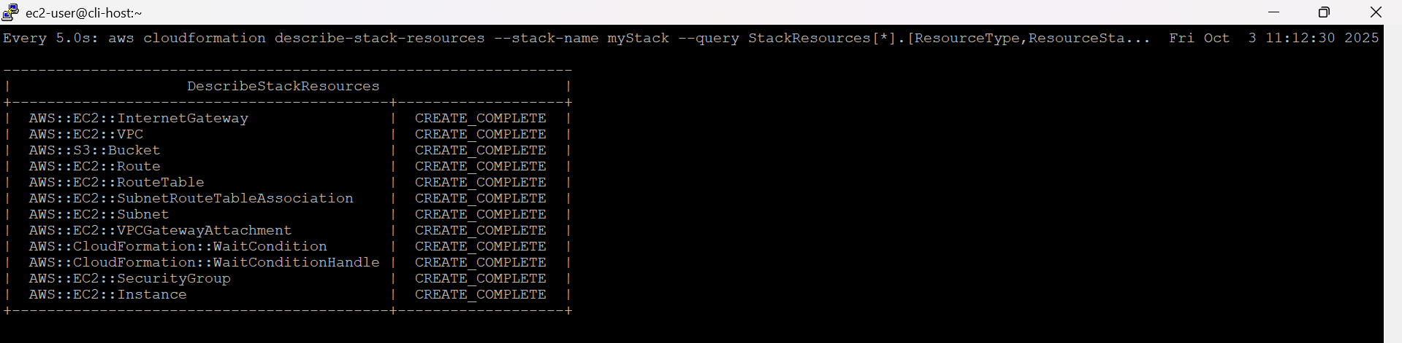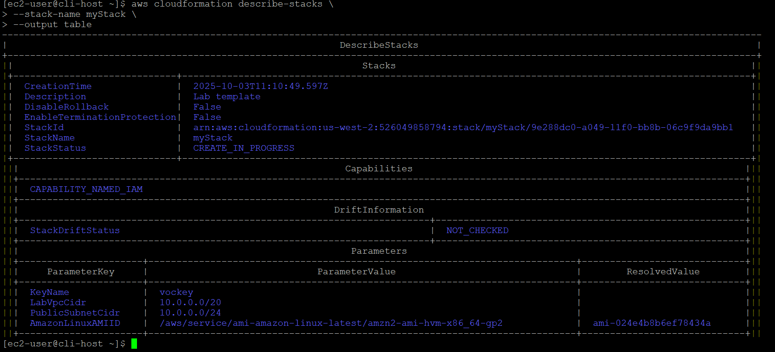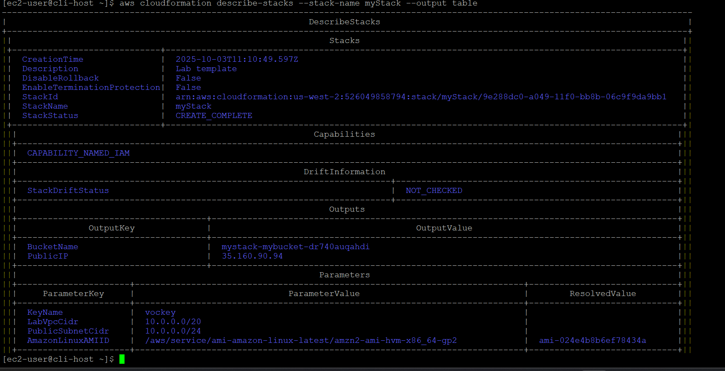
PublicIP | 35.160.90.94
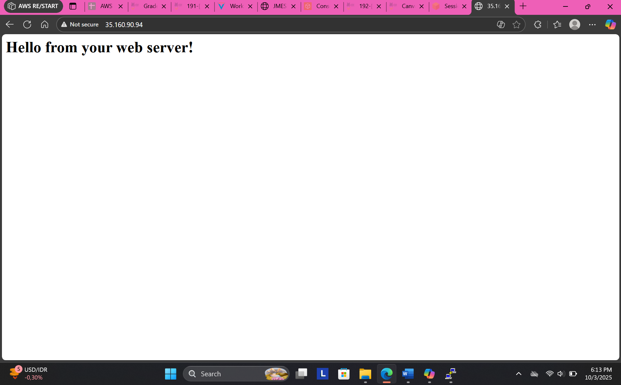Task 3: Make manual modifications and detect drift
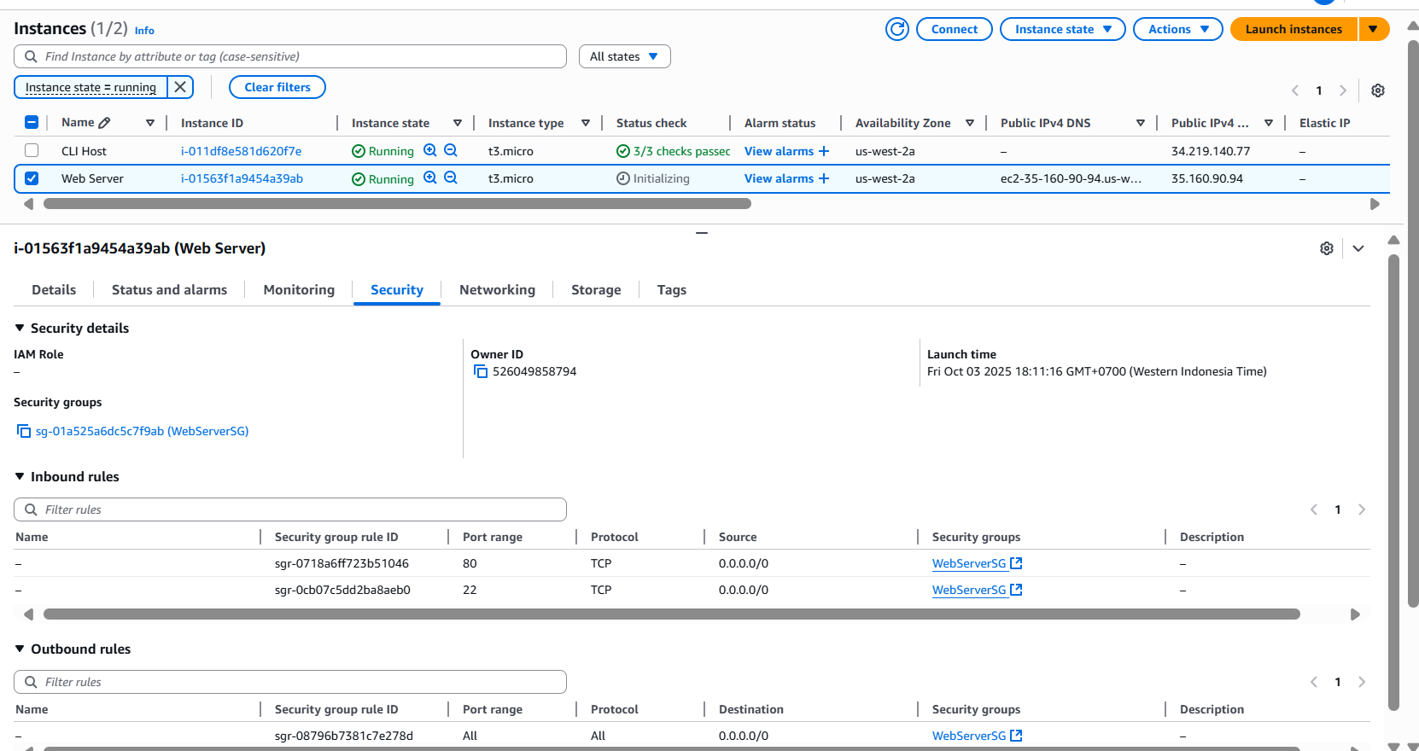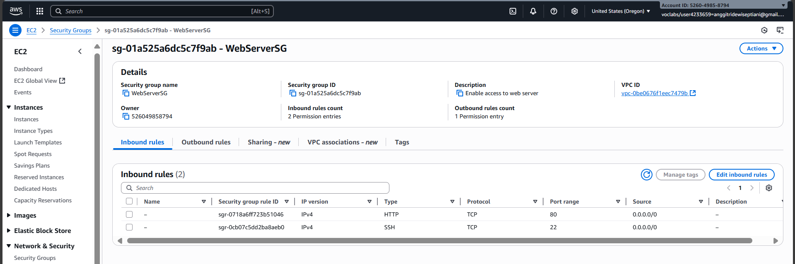
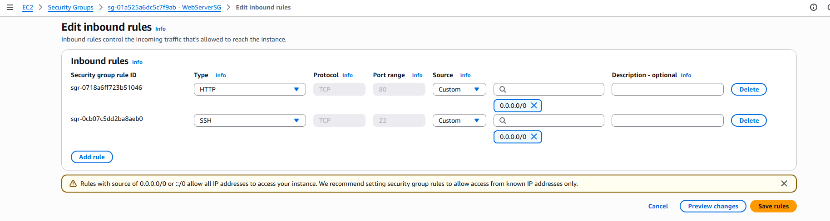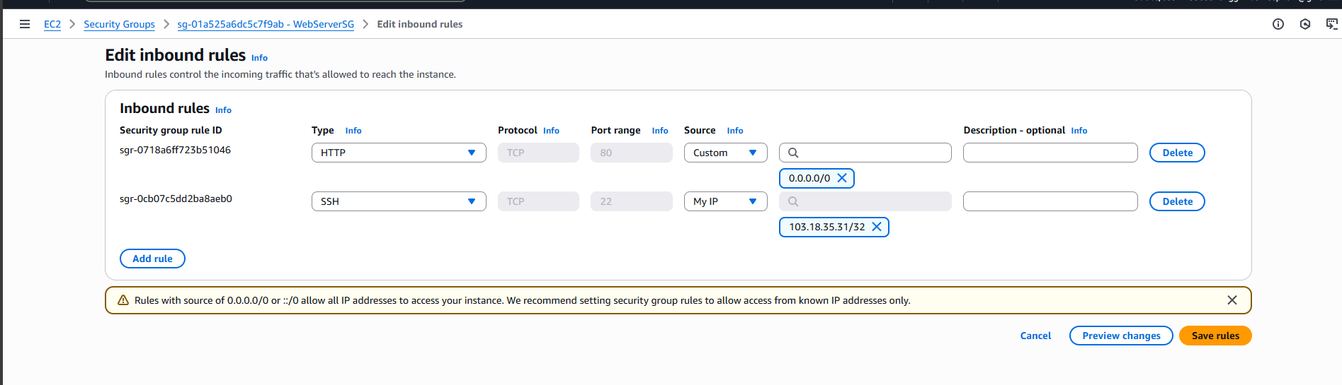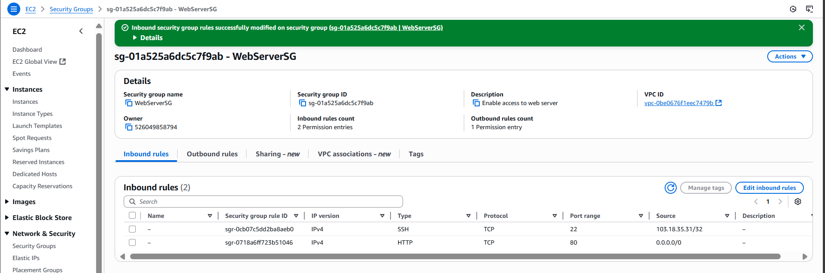
Task 3.2: Add an object to the S3 bucket.
bucketName=$(\
aws cloudformation describe-stacks \
--stack-name myStack \
--query "Stacks[*].Outputs[?OutputKey \
== 'BucketName'].[OutputValue]" \
--output text)
echo "bucketName = "$bucketName
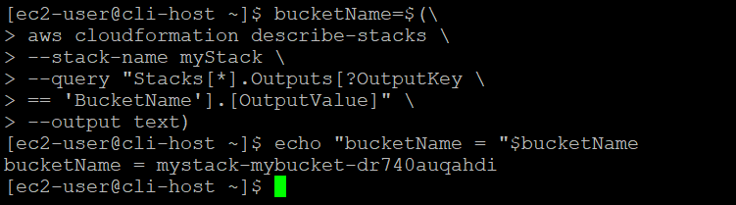
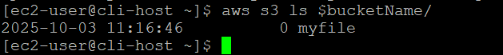
Task 3.3: Detect drift
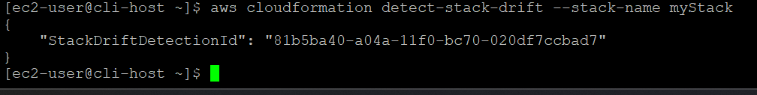
aws cloudformation describe-stack-drift-detection-status \
--stack-drift-detection-id 81b5ba40-a04a-11f0-bc70-020df7ccbad7
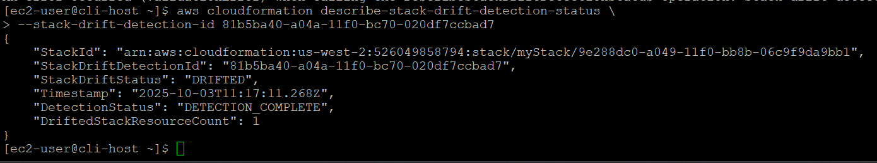
aws cloudformation describe-stack-resource-drifts \
--stack-name myStack
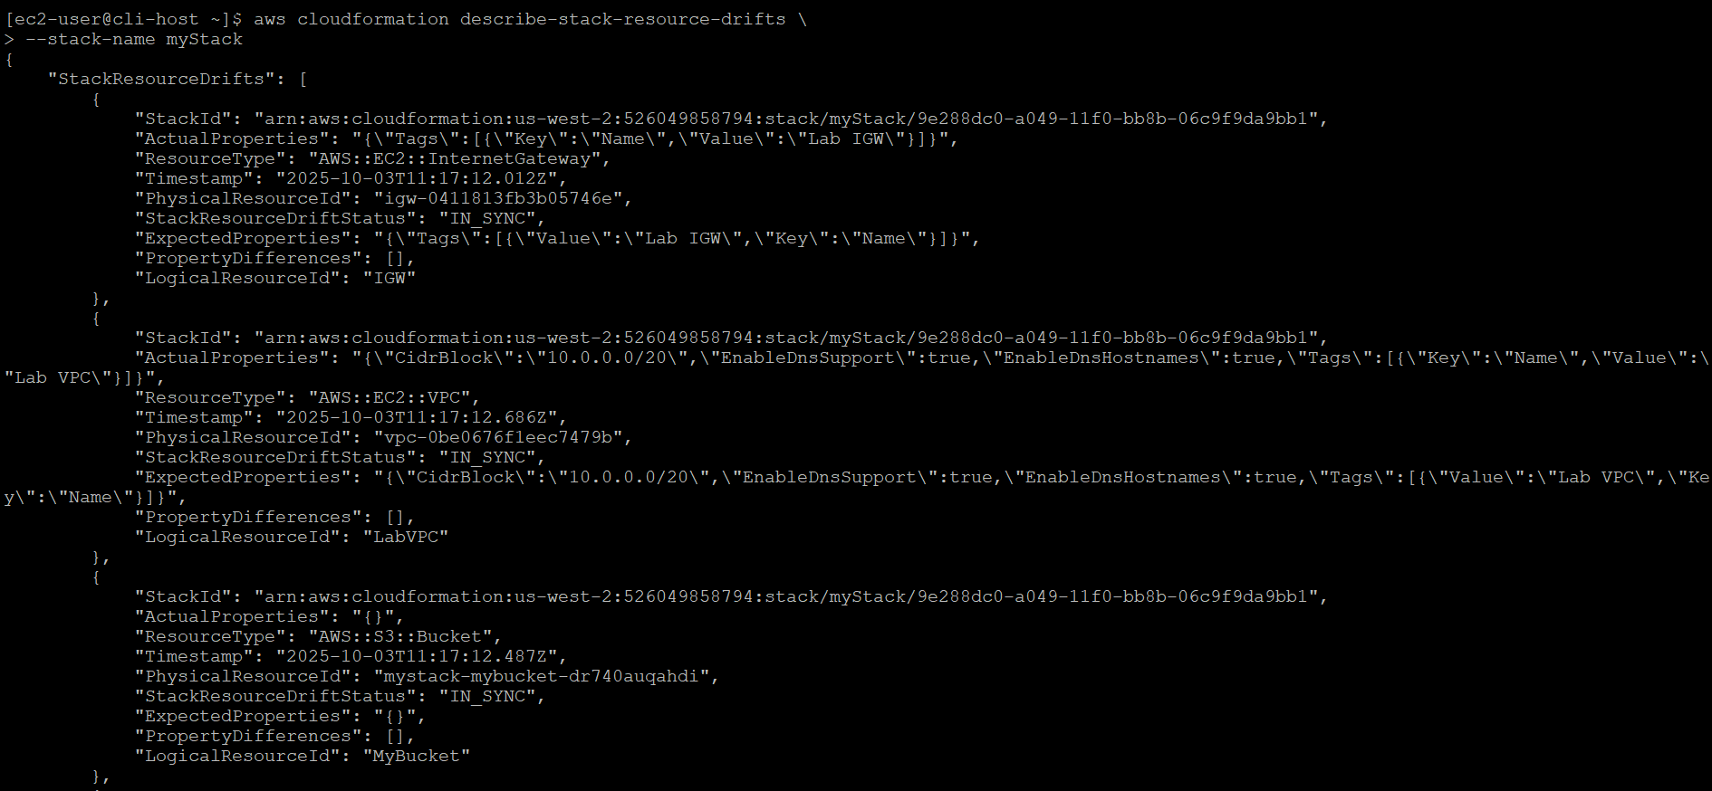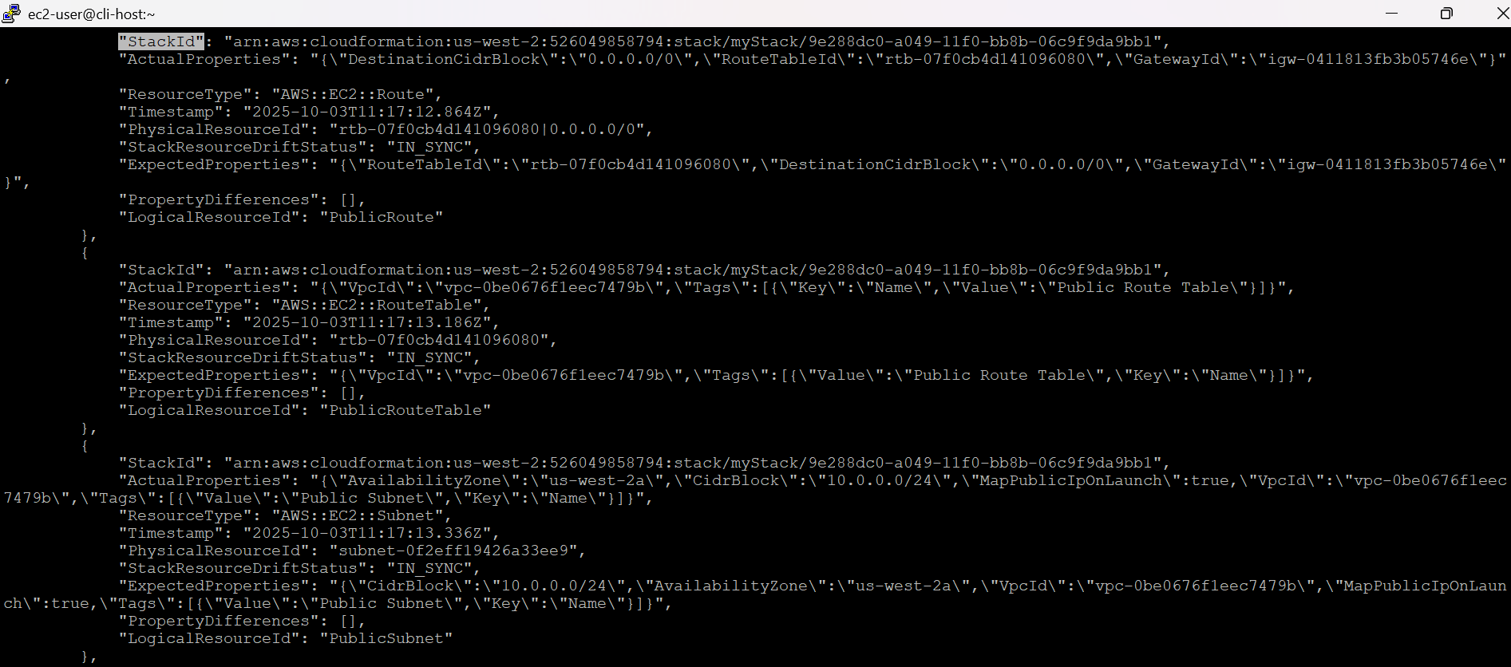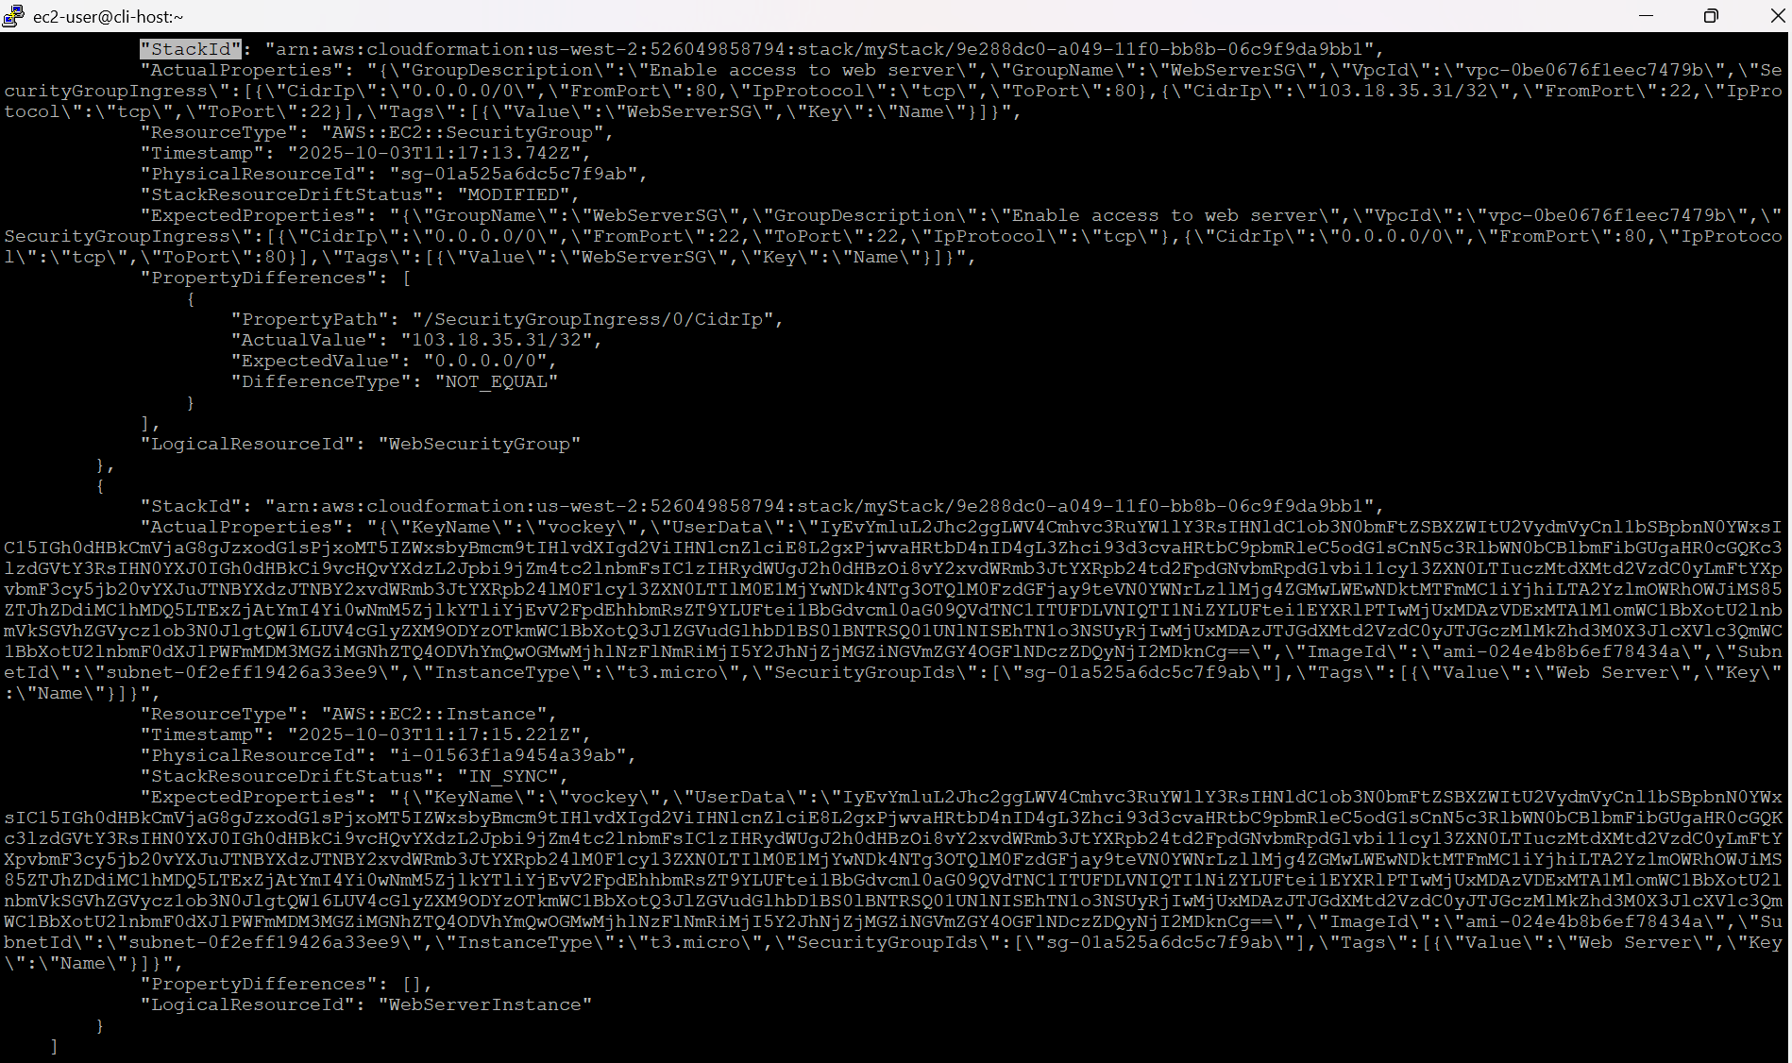
aws cloudformation describe-stack-resources \
--stack-name myStack \
--query 'StackResources[*].[ResourceType,ResourceStatus,DriftInformation.StackResourceDriftStatus]' \
--output table

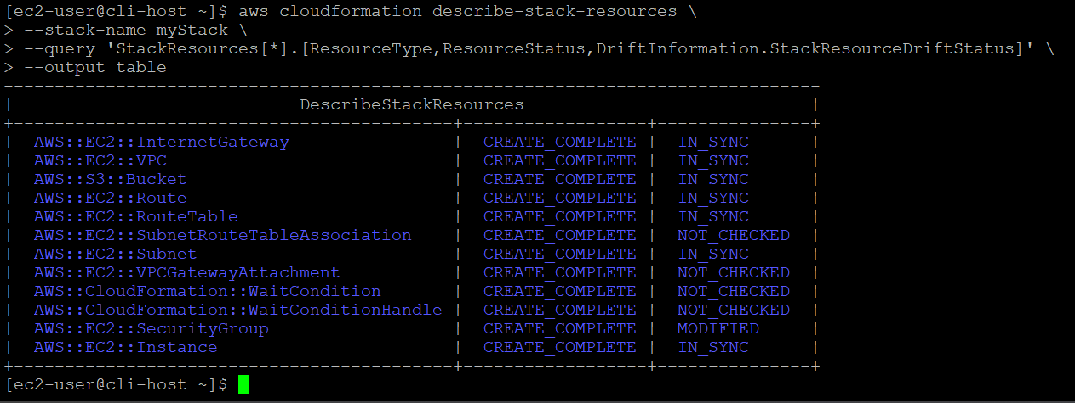
aws cloudformation describe-stack-resource-drifts \
--stack-name myStack \
--stack-resource-drift-status-filters MODIFIED

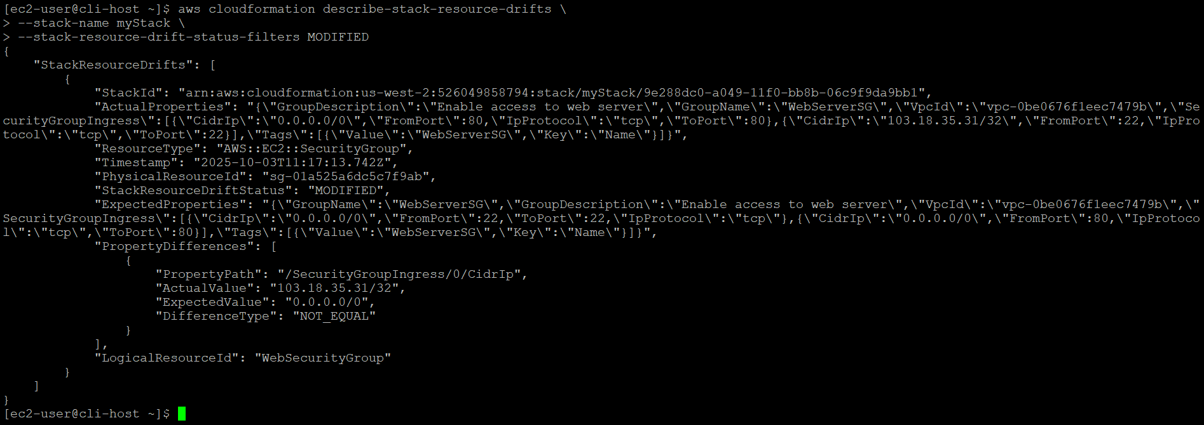
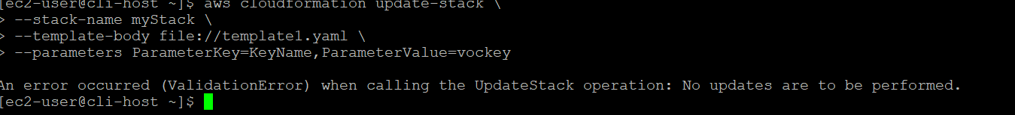
The output should indicate that an error occurred. This is expected.
The update-stack command will not automatically resolve drift, though drift has occurred. You must manually resolve these issues to eliminate the drift.
Task 4: Attempt to delete the stack
Try deleting the stack by running the following command:
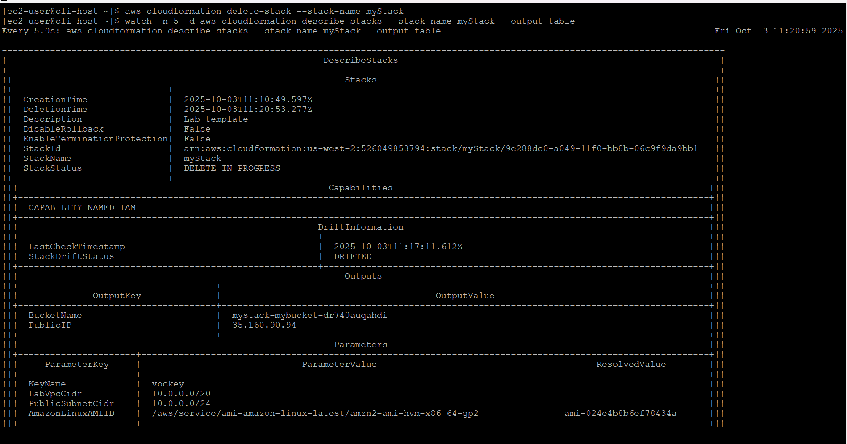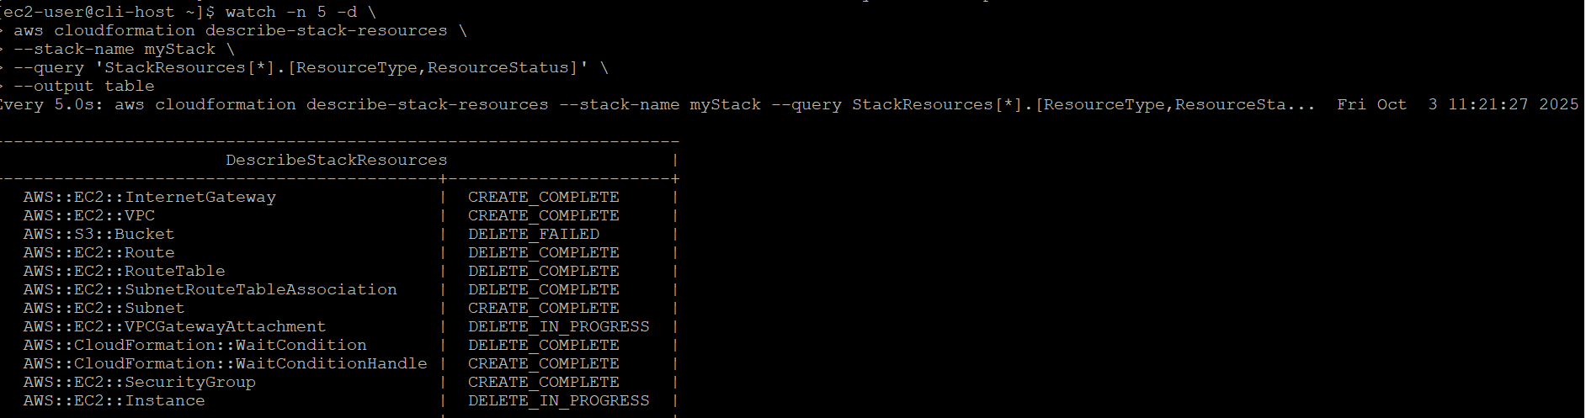
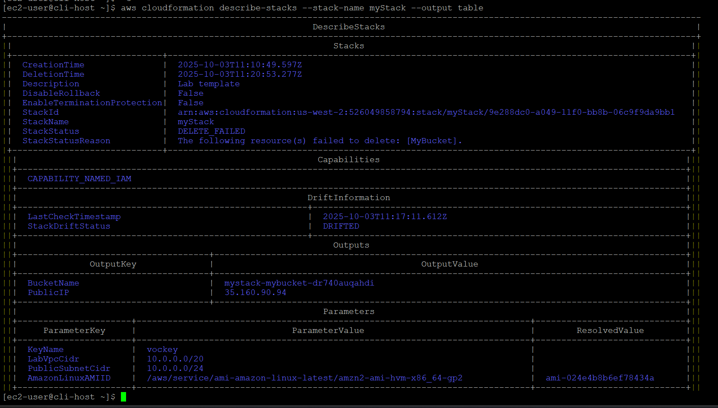

Challenge: Keep the file in the S3 bucket, but Still Delete the Stack
- Cek my stack
aws cloudformation describe-stack-resources \
--stack-name myStack \
--query 'StackResources[*].[ResourceType,ResourceStatus,DriftInformation.StackResourceDriftStatus]' \
--output table

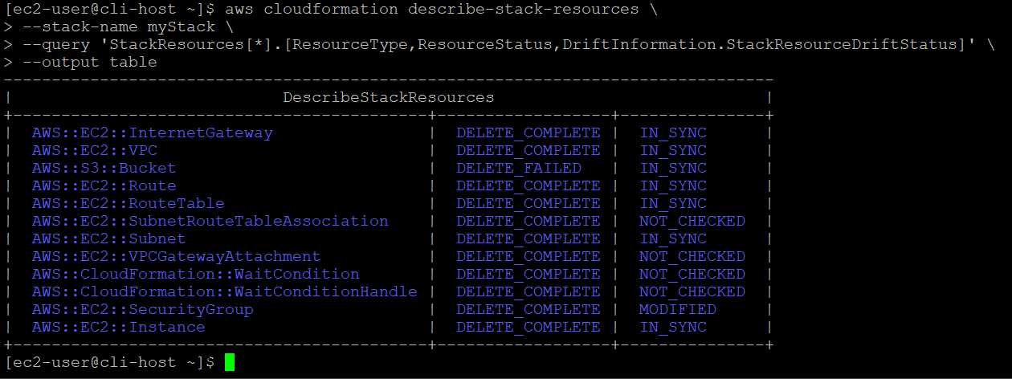
- Cek bucket name
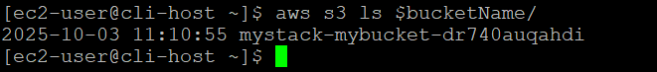
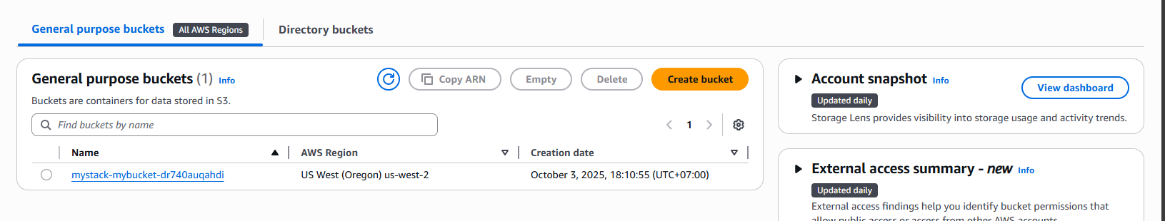
- Delete stack without delete bucket use commane
aws cloudformation delete-stack \
--stack-name myStack \
--retain-resources mystack-mybucket-dr740auqahdi

Namum masih ada eror
- Check progress delete stack
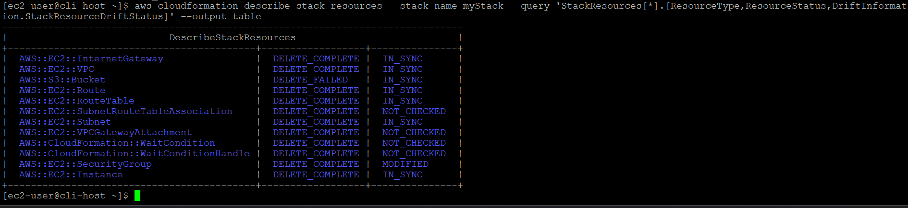

- Cek stack mana saja yg belum berhasil di delete
aws cloudformation list-stacks \
> --query "StackSummaries[?StackStatus!='DELETE_COMPLETE'].StackName" \
> --output table
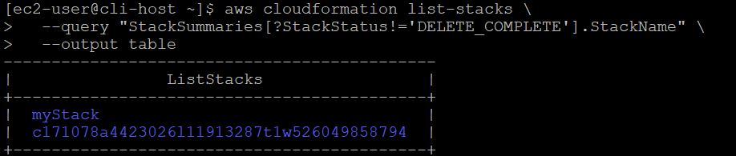
Disini stack mystack belum berhasil di delet

- Check status stack

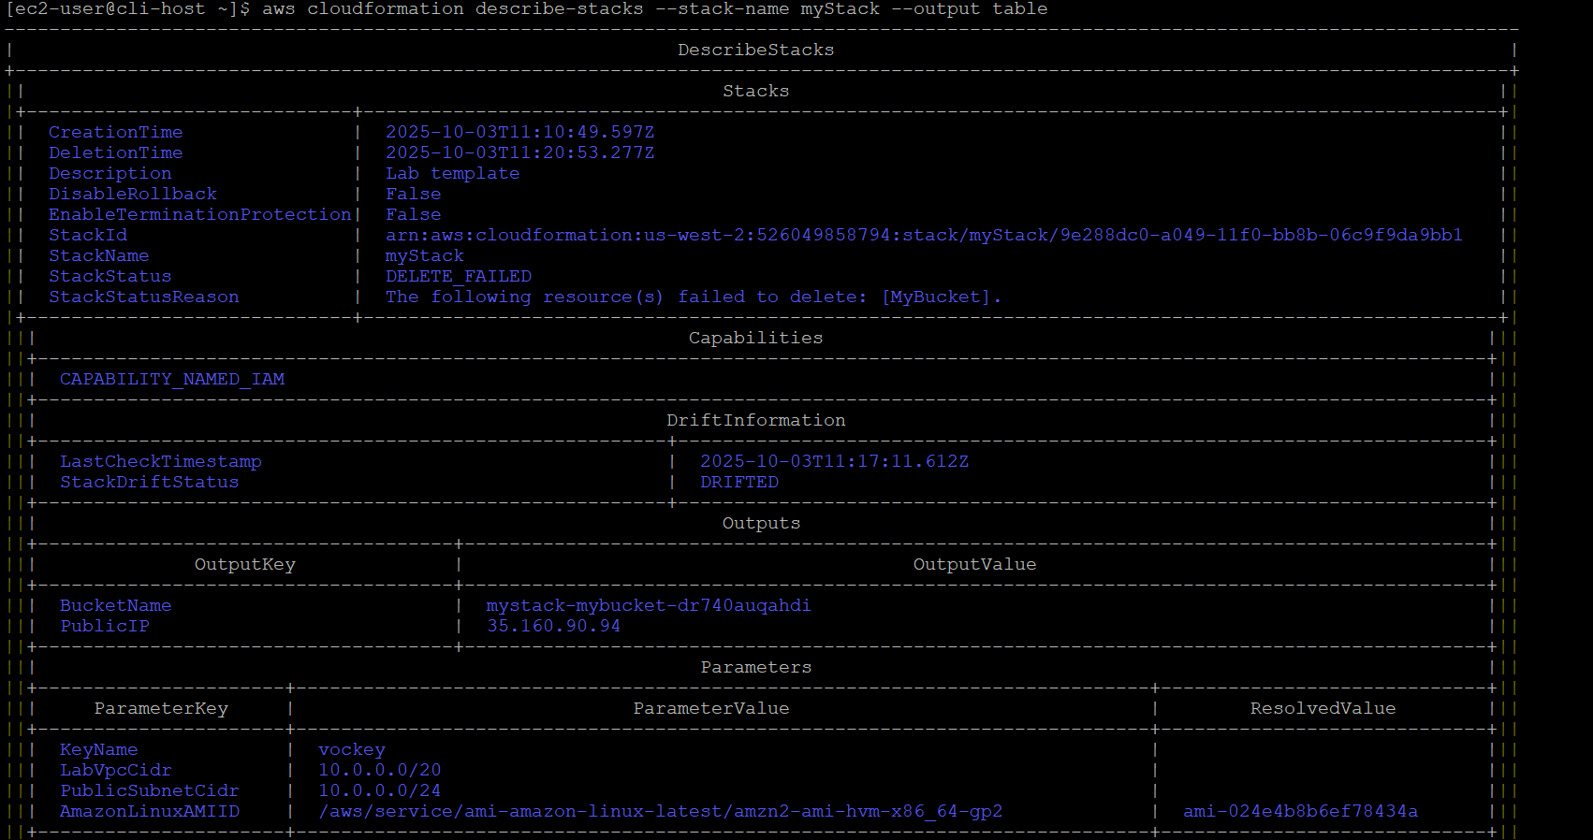

- Cari LogicalResourceId
aws cloudformation describe-stack-resources \
> --stack-name myStack \
> --query "StackResources[?ResourceStatus=='DELETE_FAILED'].LogicalResourceId" \
> --output text
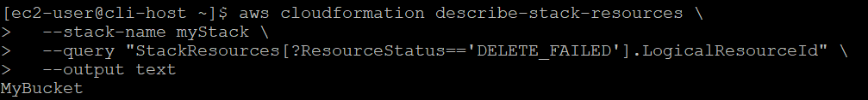
- Delete stack dan pertahankan bucket s3
aws cloudformation delete-stack \
> --stack-name myStack \
> --retain-resources MyBucket
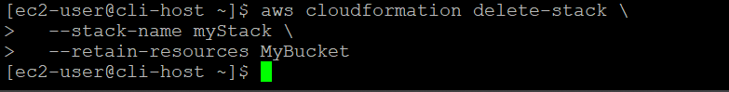

- Cek lagi apakah ada yg status stacknya tidak berhasil
Disini dicek sudah berhasil karena tidak ada Mystack

Jadi challenge is complete

